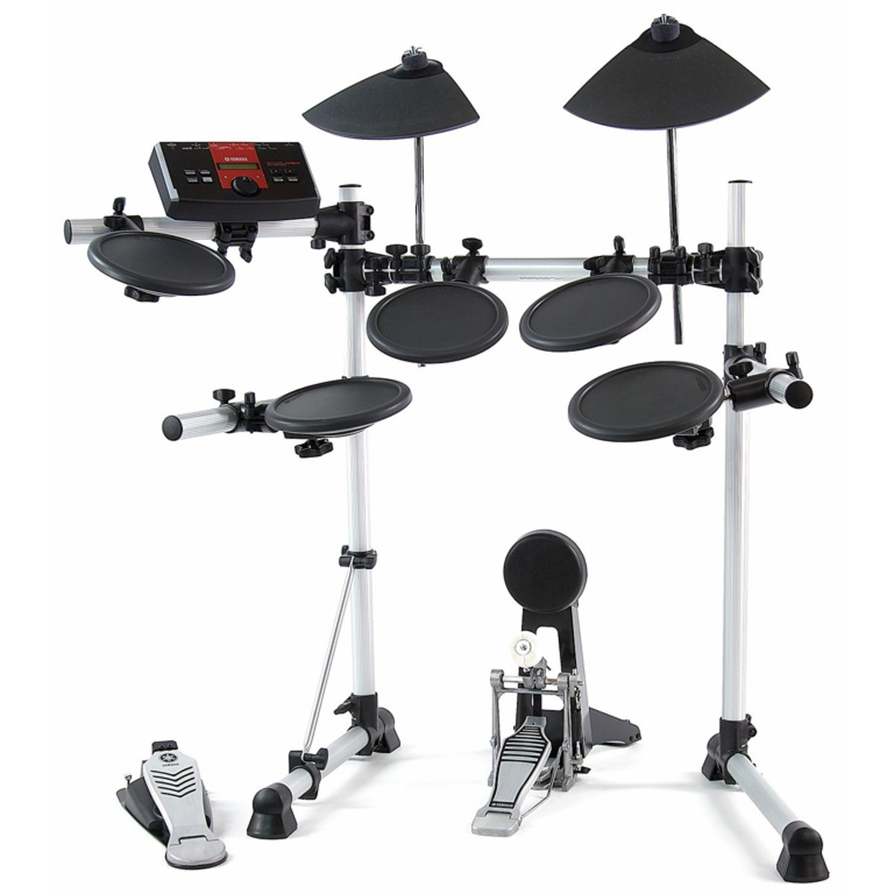

Name all the parts on the Drum Kit

What was the name of the Drummer? _____________________________