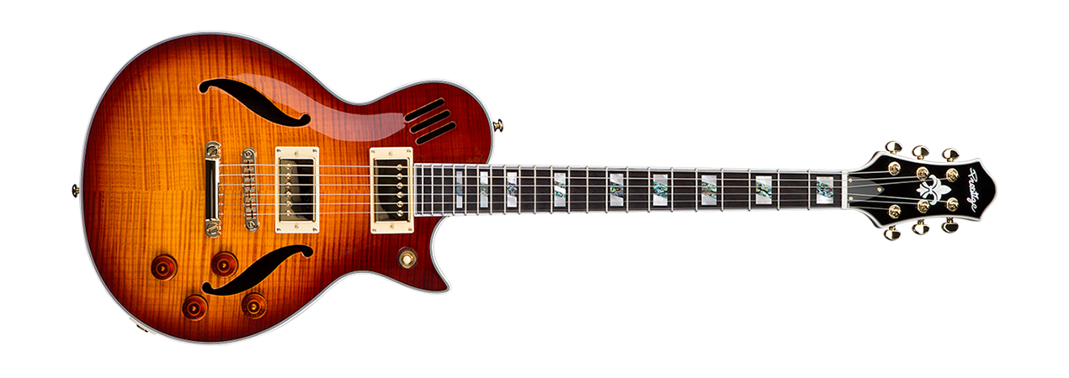

What is the name of the Guitar Player? __________________

Name all the parts on the Guitar